Supplementary Text 1 - Lab protocols

The lab protocols are published in:

Christopher G Jacob, Nguyen Thuy-Nhien, …, Dominic P Kwiatkowski, Olivo Miotto (2021) Genetic surveillance in the Greater Mekong subregion and South Asia to support malaria control and elimination eLife 10:e62997

With the following modifications for application to An. gambiae:

Comparison of Pf and Ag-vampIR protocol
Protocol | Feature | Pf | Ag-vampIR
Overall protocol | Number of panels | 3 | 1
PEP/sWGA | Whole genome amplification | sWGA | PEP
 | Conc for T&B samples | 1.33ng/ul | 1ng/ul
Library prep  (T&B / Operational) | PCR_1 thermocycler parameters | 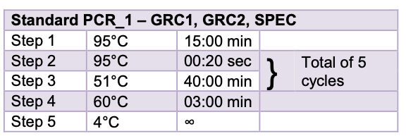  Annealing temp = 51C | 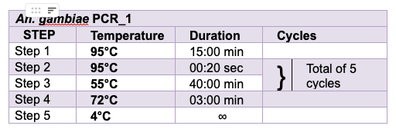  Annealing temp = 55C
Library prep  (T&B / Operational) | PCR_2 thermocycler parameters | 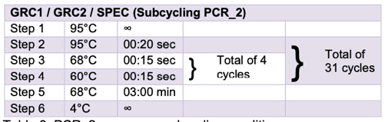  Temp cycles between 68C and 60C for 15s each | 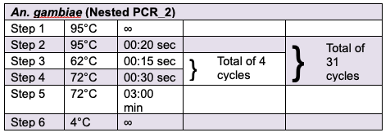  Temp cycles between 62/72C for 15.30s
PCR_1 | Primer number | 136 (68,66,2) | 80
qPCR | Dilutions | 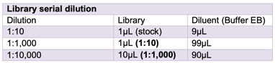  Dilutions 1:1k and 1:10k used | 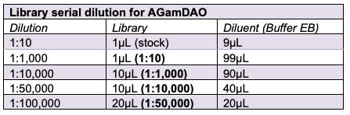  Additional dilutions required if PEP is used including 1:50k and 1:100k

